# Butterfly Museum Specimens

Morphological Responses to Climate Change: A Case Study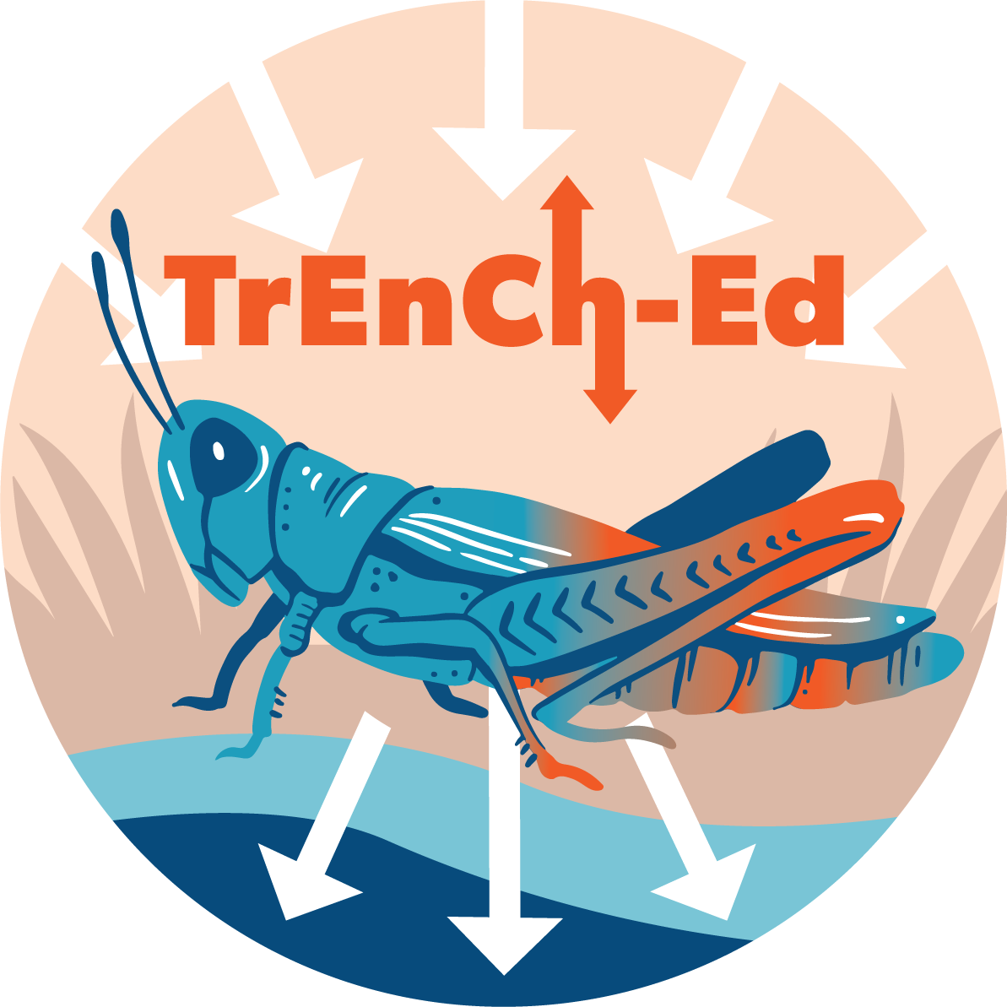

## [Link to the visualization](https://huckley.shinyapps.io/butterflies/)

## [Link to TrEnCh-Ed](https://trench-ed.github.io/#)

## Objectives

* Analyze case study data to create an explanation about how climate might influence species such as the *Colias* butterflies.
* Understand how thermoregulatory traits (e.g., coloration, size) influence how organisms interact with their environment.
* Examine how climate change can drive changes in thermoregulatory traits

## Cross-cutting concepts -- *Next Generation Science Standards*

* Patterns
* Cause and effect
* Energy and Matter
* Structure and function
* Stability and change

## Cross-cutting concepts -- *Other*

* Change vs variability
* Data reasoning

## Standards

Life Science Standards (LS)

|  |  |
| --- | --- |
| **Performance Expectation** | **Students who demonstrate understanding can...** |
| HS-PS2-2 | Use mathematical representations to support and revise explanations based on evidence about factors affecting biodiversity and populations in ecosystems of different scales. |

Advanced Placement Environmental Science

|  |  |
| --- | --- |
| 2.6 - Describe how organisms adapt to their environment. | * **ERT-2.H.1-** Organisms adapt to their environment over time, both in short- and long-term scales, via incremental changes at the genetic level. * **ERT-2.H.2** - Environmental changes, either sudden or gradual, may threaten a species’ survival, requiring individuals to alter behaviors, move, or perish. |

## Background

Read the introduction to the visualization and answer these background questions below.

### Museum specimens hold clues to organisms’ physical changes

1. What response to recent climate change did researchers document in many species?
2. What do they think are the two reasons for this response?

### Warmth is life or death for *Colias* butterflies

1. What is the habitat of the *Colias* butterflies?
2. Define thermoregulation:
3. How do *Colias* butterflies thermoregulate?

### Pulling data out of specimen drawers

1. Where were the *Colias* butterflies found in this study?

### Taking trait measurements

1. Summarize how MacLean measured the three morphological traits.
2. In the next and final set of questions, you will be analyzing variables about the *Colias* butterflies. Give a definition of each of the following measurements and how they were collected using information given in the reading.
   1. Seasonal temperature:
   2. Pupal temperature:
   3. Wing melanism:
   4. Forewing length:
   5. Setae length:

## Questions

In this exercise, you will be able to create graphical representations using multiple variables. You will be attempting to evaluate a graph and then will be able to make changes according to your hypotheses. Try to answer some of the following questions by changing the data you plot. For each question, consider whether you see the same patterns at all three sites, or if different populations respond differently. Recall how each population occupies a different elevational range. How might this affect their responses? Click the hint buttons for some help.

1. What is the variable present on the x-axis (horizontal)?
2. Change the y-axis to represent the seasonal temperature. Have spring and summer temperatures increased over the years? If so, at which sites?
3. Change the y-axis to measure the forewing length. Has forewing length decreased over the years? If so, at which sites?
4. Have the butterfly wings lightened over the years?
   1. To answer this question, what should you change on the graph to measure the pigmentation of the butterfly wings?
   2. Make this change to the graph. Have the butterfly wings lightened over the years?

Why might this be? One thing to consider is that butterflies in the Southern Rocky Mountains are living at extremely high elevations, where conditions even after warming are colder than the other sites. Here, darker wings could allow the butterflies to take advantage of warming to fly farther and longer, especially if shifting phenologies are causing them to be active earlier and later in the season when things are cooler than in midsummer. Also, temperatures fluctuate more dramatically at high elevation, meaning even if it's warmer on average, darker wings are still beneficial in very cool days or years.

1. Using the visualizations, have forewings or setae length changed over the years?

This is a surprising result, since they all point toward the butterflies increasing their ability to retain heat even though the climate has warmed.

1. How do spring and summer temperatures affect the day of year when butterflies reach adulthood? *(Hint: x-axis = season temperature)*

This functions how we would expect it to! However, if you plot Year on the x-axis, there is no clear pattern—meaning average butterfly phenology hasn't advanced over the years.

## **Analysis**

It is difficult to predict how individual populations will behave in the face of change. It is important that data are collected to allow for testing of both simple and complex hypotheses to help forecast responses to climate change.

Using the visualization in the section “Exploring butterfly morphological data”, create and test your own hypothesis. Don’t make changes until you have a prediction!

If you need additional hints, fill out the following sections:

* What is your prediction/hypothesis?
* What is your chosen x-axis variable?
* What is your chosen y-axis variable?

Run your test using the visualization.

* What did you observe?
* Was your hypothesis correct? Explain.